AN ASSESSMENT ON GLOBAL EDUCATION DATA ANALYSIS
Individual Report By: Bernard Destiny Etop

Track no.: 22/132033

Dataset: GLOBAL EDUCATION DATASET

Group 1
SUBMITTED TO DR. MRS. SYLVIA OLADIMEJI (HOD)

IN PARTIAL FULFILMENT OF THE REQUIREMENT TO THE DEPARTMENT OF MATHEMATICS & COMPUTER SCIENCE

FACULTY OF NATURAL AND APPLIED SCIENCE ARTHUR JARVIS UNIVERSITY, AKPABUYO, CROSS RIVER STATE.

January 2026.

1. Overview of the Project Domain
Education metrics and socioeconomic indicators are critical for understanding global development. This analysis focuses on the Global Education Dataset, examining various factors such as school completion rates, literacy, and proficiency in core subjects. By exploring these metrics alongside economic data like unemployment rates, the project aims to identify patterns in educational outcomes and labor market conditions across different countries and areas.

2. Introduction to the Dataset
- Dataset Name: Global Education Dataset
- Number of Instances/Rows: 202
- Number of Features/Columns: 29
- Key Features: Latitude, Longitude, Out-of-School Rates (OOSR) for various age groups, Completion Rates (Primary/Secondary), Proficiency in Reading and Math (Grade 2, 3, and End of Primary), Youth Literacy Rates, Birth Rate, Gross Enrollment, and Unemployment Rate.
- Target Variables Analyzed: Unemployment Rate and Grade 2/3 Reading Proficiency.

3. Description of the Problem or Questions Explored
The analysis seeks to address the following questions:
- How is the unemployment rate distributed globally across the represented countries?
- What is the geographic distribution of reading proficiency for children in early grades (Grade 2 and 3)?
- Which countries or areas exhibit the highest total unemployment rates?

4. Data Cleaning Steps
The dataset underwent a systematic cleaning and verification process in Python using the pandas library:
- Initial Inspection: The data was loaded using ISO-8859-1 encoding to ensure all international characters were correctly processed.
- Duplicate Check: The dataset was checked for duplicate records; no duplicate rows were found.
- Missing Value Analysis: A comprehensive check for null values across all 29 columns was performed. The result showed 0 missing values for every feature, including critical columns like "Countries and areas," "Reading Proficiency," and "Unemployment Rate".
- Feature Verification: Column names were reviewed to confirm the presence of necessary socioeconomic and educational metrics for analysis.

5. Dashboard Explanation and Insights
The analysis utilizes visualizations created with Seaborn, Matplotlib, and Plotly to provide a storytelling sequence of global education and economic health.
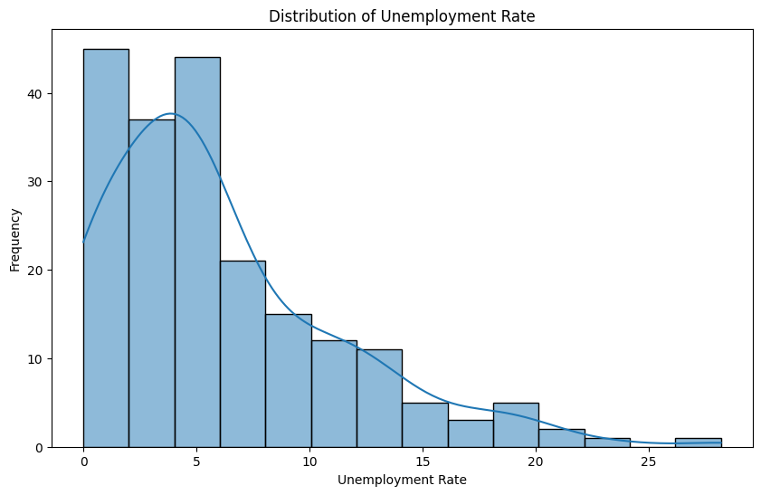 Title: Distribution of Unemployment Rate
- Description: A histogram with a Kernel Density Estimate (KDE) showing the frequency of various unemployment levels across the 202 countries.
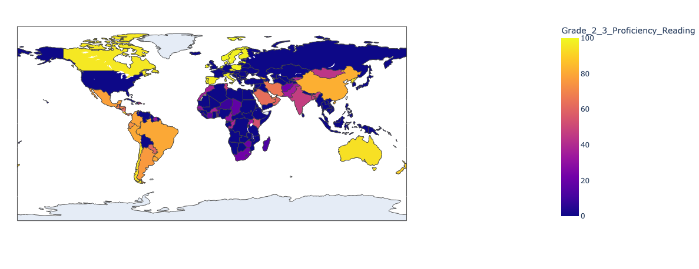
- Insight: Provides an overview of the global labor market spread, identifying where most countries fall in terms of unemployment frequency.
Title: Proficiency in Reading by Country
- Description: An interactive global map coloring countries based on their Grade 2 and 3 reading proficiency scores, ranging from 0 to 100.
- Insight: Geographic visualization reveals significant disparities in early-grade literacy. For example, some countries show high proficiency (e.g., Australia at 94, Argentina at 76), while others report much lower figures (e.g., Afghanistan at 22).
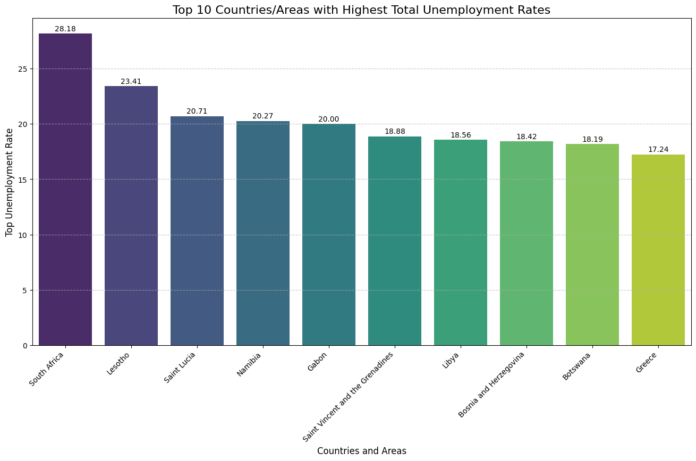 Title: Top 10 Countries/Areas with Highest Total Unemployment Rates
- Description: A bar chart identifying the 10 countries with the highest cumulative unemployment figures as recorded in the dataset.
- Insight: Directly highlights the regions facing the most significant labor challenges, allowing for targeted comparison against their educational metrics.

6. Conclusion
The analysis of the Global Education Dataset confirms a wide variance in both educational proficiency and economic stability across 202 countries. Preliminary findings through data cleaning confirmed a high-quality dataset with no missing or duplicate records. Visualizations highlighted specific regional differences in reading proficiency and identified those countries currently reporting the highest unemployment rates. This work provides a foundation for further correlation analysis between literacy rates and employment outcomes.

REFERENCES
- Source Data: Global_Education.csv
- Analysis Tool: Jupyter Notebook (ben.ipynb)
- Libraries Used: Pandas, NumPy, Matplotlib, Seaborn, Plotly

